Project Documentation and Report:

SHORT TERM INTERNSHIP ON SALES FORCE

Project Title: **Creation Of An Application For School Management-DEVELOPER – (Short-Term)**

Industry Mentor: Nadeem

Faculty Mentor: S. Asif Alisha

Team ID: LTVIP2023TMID10758

Team Size: 6

Team Leader: PERNAPATI SUPRAJA

Team member : NADIVEEDHI SHANMUGA REDDY

Team member : SANNAPANENI TEJESH

Team member : BANDI SYAM KUMAR

Team member : AMARAVATHI VASANTHI

Team member : RAYALAM VENU SREE

**PROJECT REPORT ON**

**Creation Of An Application For School**

**Management**

**Developer - (Short-Term)**

**Skills Required:**

Salesforce Developer

**Project Description:**

The project aim is to provide real-time knowledge for all the students who have basic knowledge of Salesforce and Looking for a real-time project. This project will also help those professionals who are in cross-technology and want to switch to Salesforce. With the help of this project they will gain knowledge and can include it into their resume as well.

# Introduction

**Creating a developer org in salesforce.**

Go to [developer.salesforce.com](https://developer.salesforce.com/)

Click on sign up.

On the sign up form, enter the following details

a.First name & Last name – NADIVEEDHI SHANMUGA REDDY

1. Email – nadiveedishanmugareddy@gmail.com
2. Role - Developer
3. Company – Sree Vidyanikethan Degree College
4. Country - India
5. Postal Code - 517502
6. Username - NADIVEEDISHANMUGAREDDY@GMAIL.COM

## AccountActivation

Go to the inbox of the email that you used while signing up. Click on the verify account to activate your account. The email may take 5-10mins, as

## LoginToYourSalesforceAccount

1. Go to salesforce.com and click on login.
2. Enter the username and password that you just created.
3. After login this is the home page which you will see.

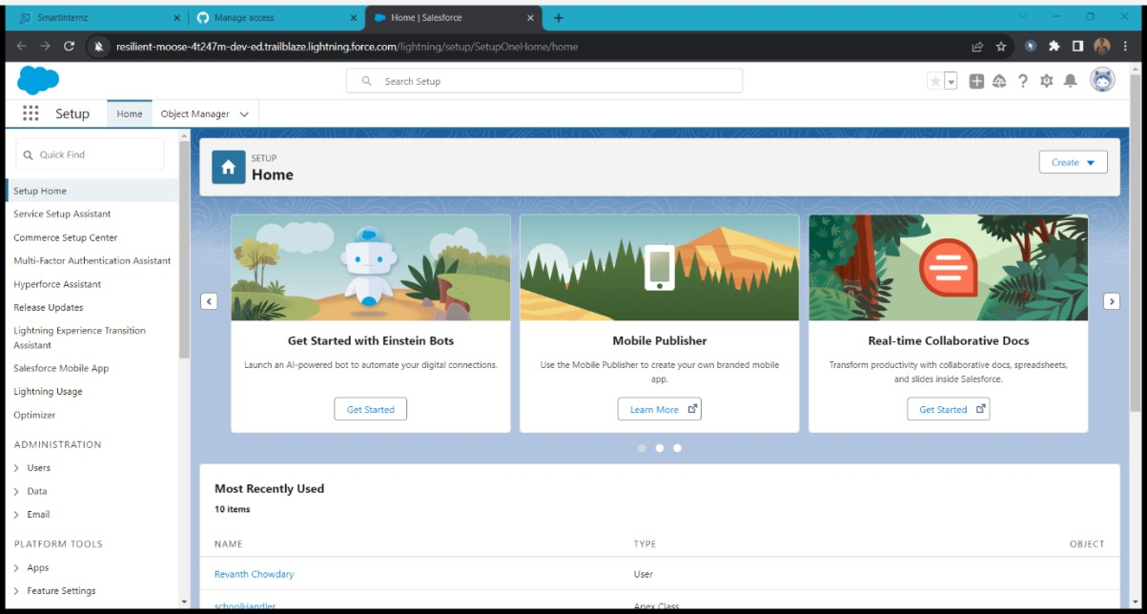

# Object

## Creation Of School Object Creation Of Objects For School Management

For this school management we need to create 3 objects School, Parents and Student. The below steps will assist you in creating those objects.

1. Click on the gear icon and then select Setup.
2. Click on the object manager tab just beside the home tab.
3. After the above steps, have a look on the extreme right you will find a Create Dropdown click on that and select Custom Object.
4. On the Custom Object Definition page, create the object as follows:
5. Label: School
6. Plural Label: Schools
7. Record Name: School Name
8. Check the Allow Reports checkbox
9. Check the Allow Search checkbox 10. Click Save.

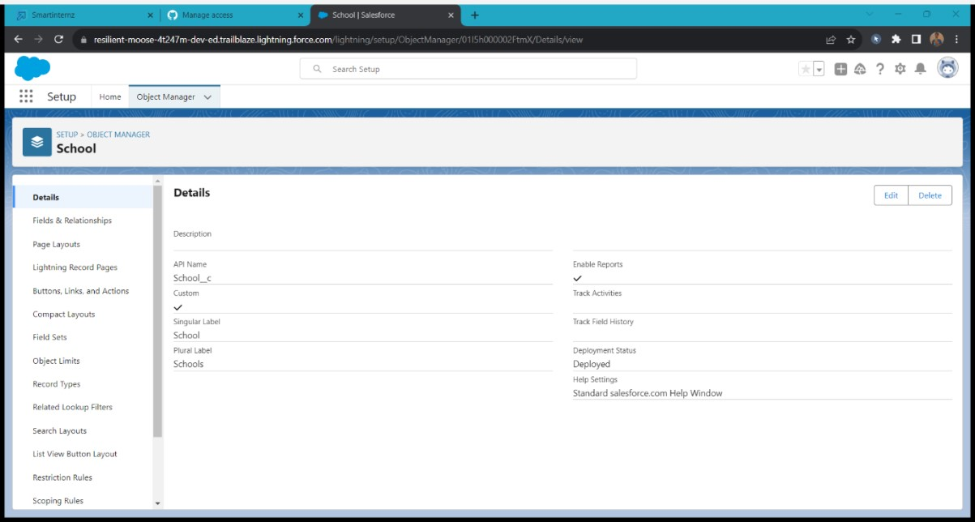

Now create a custom tab. Click the Home tab.

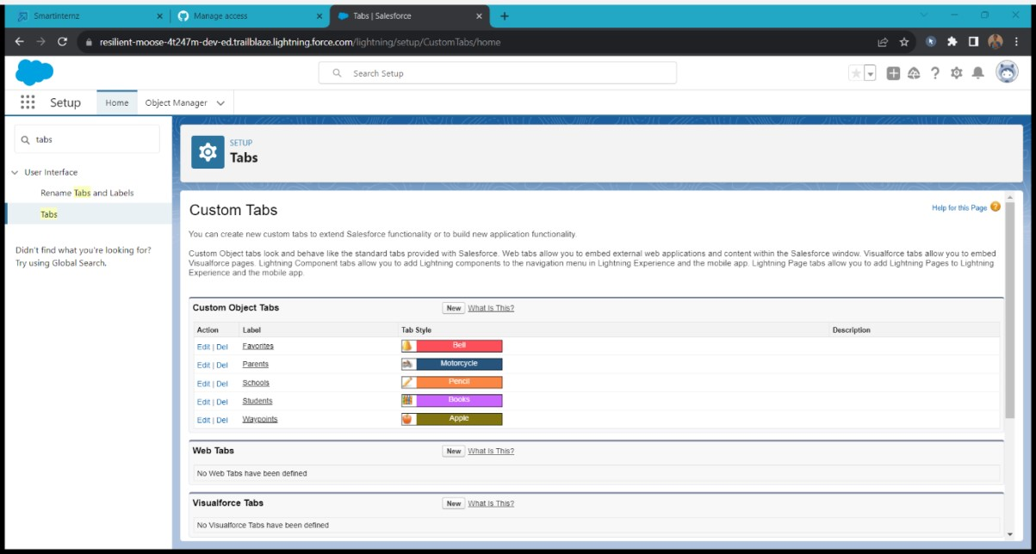

## Create Student Object

1. Click on the gear icon and then select Setup.
2. Click on the object manager tab just beside the home tab
3. After the above steps, have a look on the extreme right you will find a Create Dropdown click on that and select Custom Object.

* On the Custom Object Definition page, create the object as follows:
* Label: Student
* Plural Label: Students
* Record Name: Student Name
* Check the Allow Reports checkbox • Check the Allow Search checkbox
* Click Save.

Now create a custom tab. Click the Home tab, enter Tabs in Quick Find and select Tabs. Under Custom Object Tabs, click New.

1. For Object, select Students.
2. For Tab Style, select any icon.
3. Leave all defaults as is. Click Next, Next, and Save.

## Create Parent Object

Click on the gear icon and then select Setup.

1. Click on the object manager tab just beside the home tab.
2. After the above steps, have a look on the extreme right you will find a Create Dropdown click on that and select Custom Object.

* On the Custom Object Definition page, create the object as follows:
* Label: Parent
* Plural Label: Parents
* Record Name: Parent Name
* Check the Allow Reports checkbox • Check the Allow Search checkbox
* Click Save.

# 3.Lightning App

## Create The School Management App

From Setup, enter App Manager in the Quick Find and select App Manager.

1. Click New Lightning App.
2. Enter School Management as the App Name, then click Next 4. Under App Options, leave the default selections and click Next.
3. Under Utility Items, leave as is and click Next.
4. From Available Items, select Schools, Students, Parents, Reports, and Dashboards and move them to Selected Items. Click Next.
5. From Available Profiles, select System Administrator and move it to Selected Profiles.Click Save & Finish.

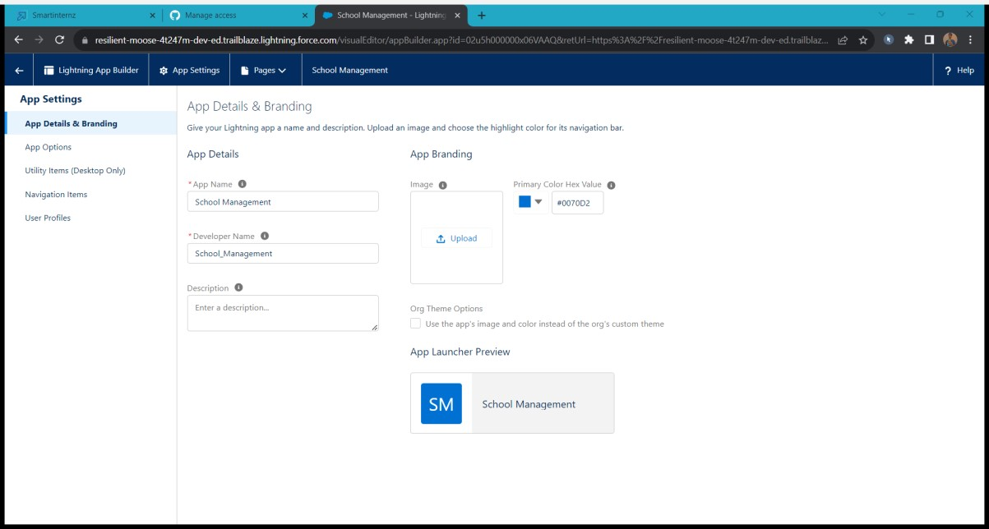

# 4.Fields And Relationship

## Creation Of Fields For The School Objects

1. Click the gear icon and select Setup. This launches Setup in a new tab.
2. Click the Object Manager tab next to Home.
3. Select School.
4. Select Fields & Relationships from the left navigation
5. Click New
6. Select the Text Area as the Data Type, click Next.
7. For Field Label, enter Address.
8. Click Next, Next, then Save & New.
9. Follow steps 1 to 3 and create two more Text type field - District & State.
10. Create URL type field & give School website as the field lab

Now let's create the other fields and we must choose the data types of the fields carefully. Let's have a look at it.

For example, a phone number is a number field. For that we need to select the phone as data

type.

Let’s see this

Note- Follow above steps 1 to 5 to create field and then follow below steps

1. Select the Phone as the Data Type, then click Next.
2. For Field Label, enter Phone Number.
3. Click Next, Next, then Save & New.

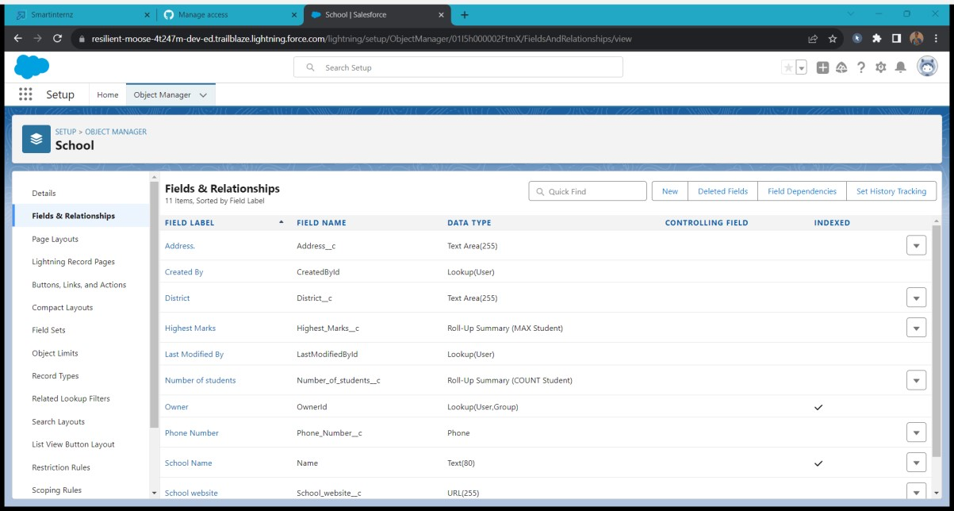

## Creation Of Fields For The Student Objects

Note- Follow above steps 1 to 5 to create field and then follow below steps

1. Select the Phone as the Data Type, then click Next.
2. For Field Label, enter Phone Number.
3. Click Next, Next, then Save & New

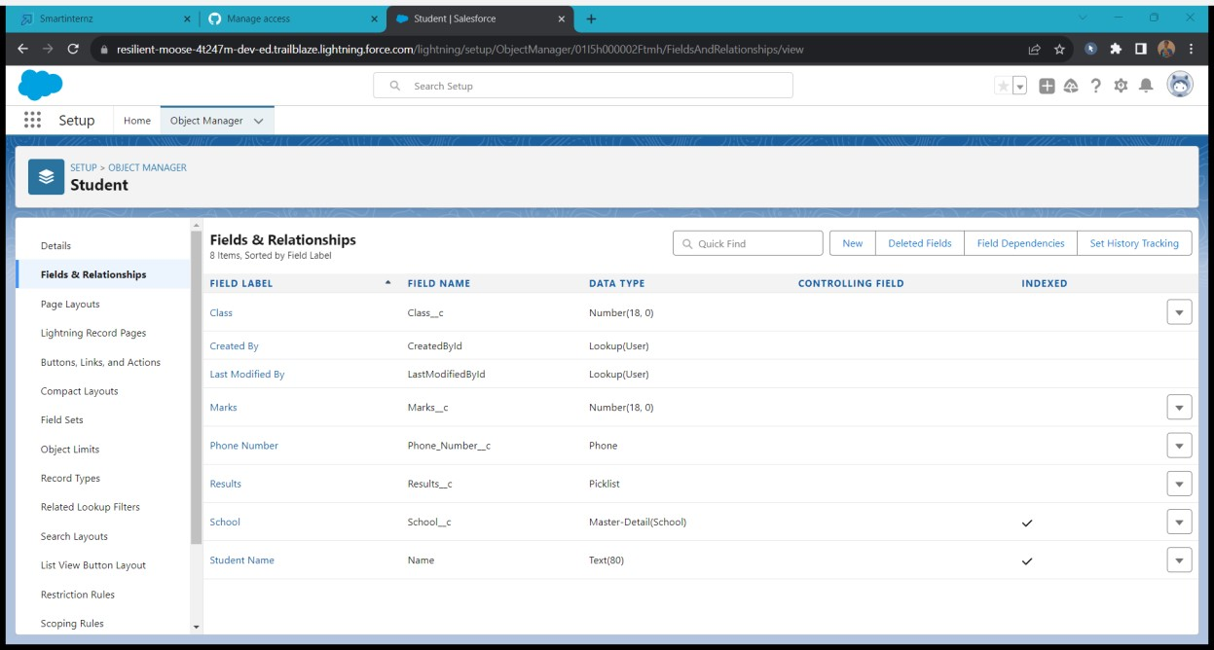

## Let'screateamaster-detailrelationshipwithSchoolobject

Note- Follow above steps 1 to 5 to create field and then follow below steps

1. Select Master-Detail Relationship as the Data Type and click Next.
2. For Related to, enter School.
3. Click Next.
4. For Field Label, enter School.
5. Click Next, Next, Next and Save.

**Let’screateaPick-Listfield:**

Note- Follow above steps 1 to 5 to create field and then follow below steps

1. From Setup, click Object Manager and select Student.
2. Click Fields & Relationships, then New.
3. Select Picklist as the Data Type and click Next.
4. For Field Label enter Results.
5. Select Enter values, with each value separated by a new line and enter these values:
6. Pass
7. Fail
8. Click Next, Next, then Save & New

Note- Follow above steps 1 to 5 to create field and then follow below steps

1. Select the Number as the Data Type, then click Next.
2. For Field Label, enter Class.
3. Click Next, Next, then Save & New
4. Follow steps 1 through 3 and create one more number field with Marks as the field labels.

**Let’s create Roll-up summary fields on School Object to calculate the number ofstudents**

1. Click gear icon Select Setup, This launches Setup in a new tab. 2. click Object Manager

1. Select School.
2. Click Fields & Relationships
3. Click New.
4. Select the Roll-up summary field as data type
5. Enter the field label as Number of students
6. Click Next
7. Then select the master object summarized as students 10. Select count as roll-up and then click Next, Next and save.

## Create one more rollup summary field-

* From Setup, click Object Manager and select School.
* Click Fields & Relationships, then New.
* Select the Roll-up summary field as data type
* Enter the field label as Highest Marks
* Click Next
* Then select the master object summarized as students and then select Max as roll-up and then select Marks as field to aggregate.
* click Next, Next and save.

## Creation Of Fields For The Parent Objects

* Select the Text Area as the Data Type, then click Next.
* For Field Label, enter Parent Address.
* Click Next, Next, then Save & New.
* Select the Phone as the Data Type, then click Next.
* For Field Label, enter Parent Number.
* Click Next, Next, then Save & New

# 5.Profile

## Creation On Profile

* From Setup enter Profiles in the Quick Find box
* Select Profiles.
* Click new, From the list of profiles, find Standard User (profile to clone) • For Profile Name, enter School Profile
* Click Save.
* While still on the School profile page, then click Edit.
* Scroll down to Custom Object Permissions and Give view all access permissions.

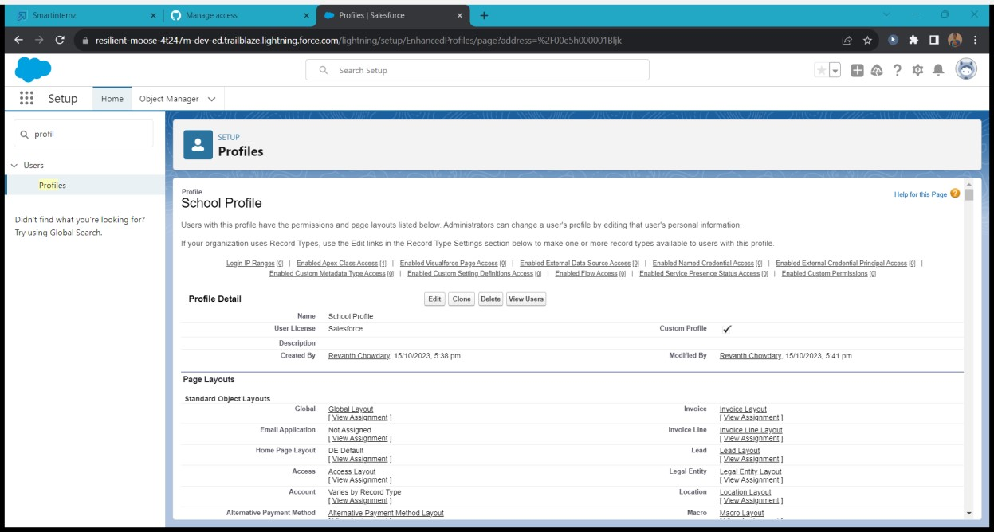

# 6.Users

## Creating A User

1. From Setup, in the Quick Find box, enter Users.
2. Select Users.
3. Click New User.
4. Enter the user’s name Parents and (Your) email address and a unique username in the form of an email address. By default, the username is the same as the email address.
5. Select a User License as salesforce.
6. NOTE- As Salesforce license can only be used by 2 Users at a time in Dev Org, so If you don’t find salesforce license then deactivate a user who has salesforce license or change the license type from Salesforce to any other.
7. Select a profile as a School profile.
8. Check Generate new password and notify the user immediately to have the user’s login name and a temporary password emailed to your email.
9. Similarly follow the above steps and create 2 users as Teachers and principals.

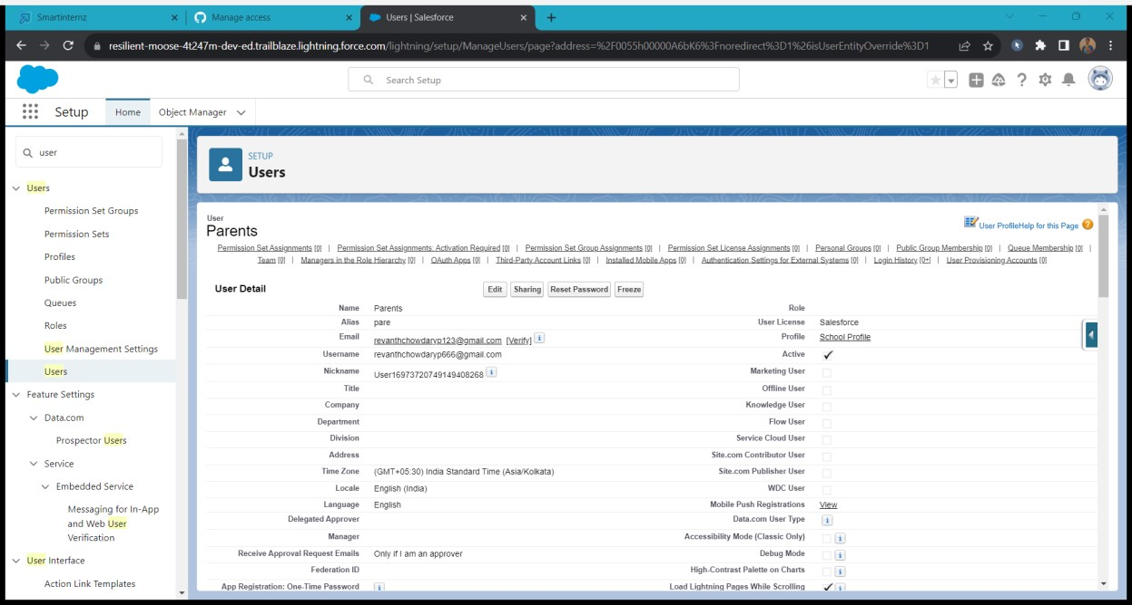

# 7.Permission Sets

## Permission Sets 1

1. From Setup, enter Permission Sets in the Quick Find box, then select Permission Sets.
2. Click New.
3. Give the name of the Permission set name as teacher permission.
4. Under the object settings give the view create and edit permissions to all 3 custom objects (By click open the object)
5. Click on manage assignment
6. Click on add assignment.
7. Click on Teacher (user), Next, Assign.

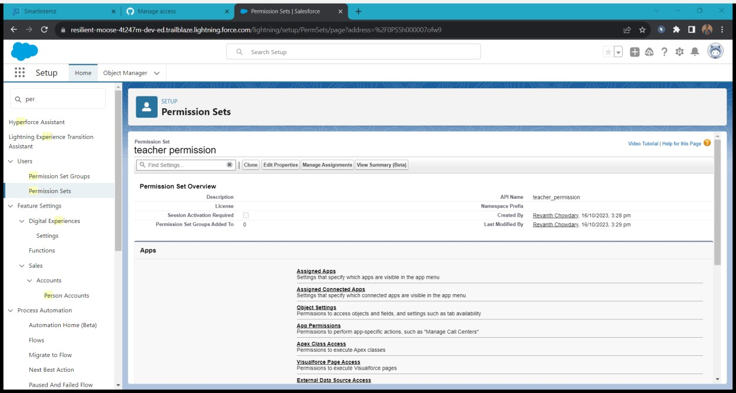

Similarly, follow the above steps for the permission set 2.

## Permission Sets 2

1. From Setup, enter Permission Sets in the Quick Find box, then select Permission Sets.
2. Click New.
3. Give the name of the Permission set name as Principal permission and then under the object settings give all permissions for the all 3 custom objects and assign them to the Principal user.

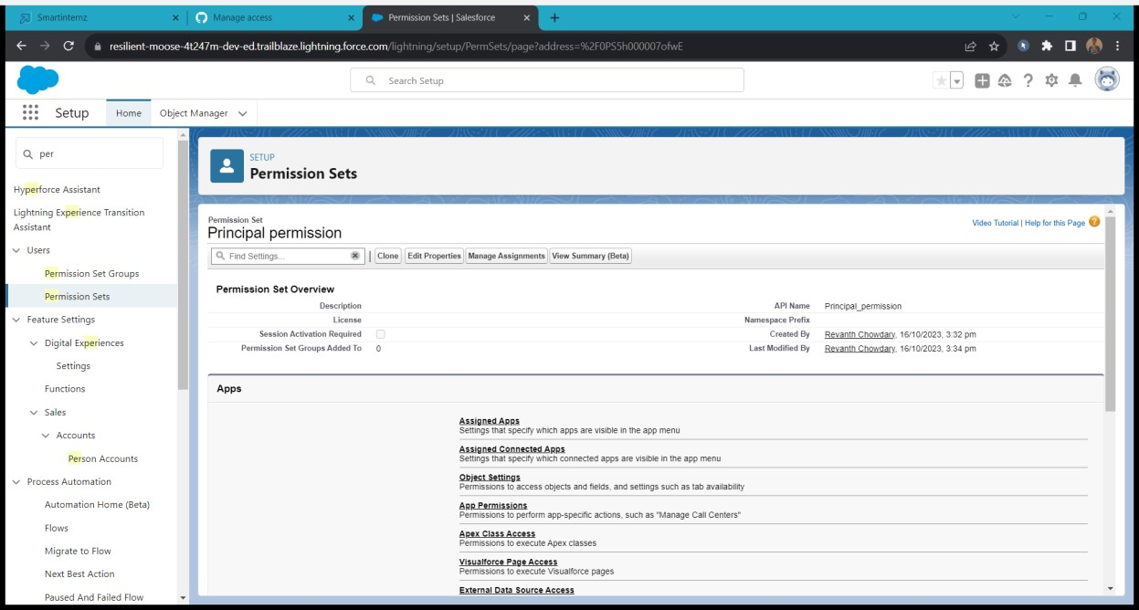

# 8.User Adoption

## Create Record (School)

1. Click on App Launcher on left side of screen.
2. Search School Management App & click on it.
3. Click on Schools tab.
4. Click new button
5. Fill all School record details.
6. Click on Save Button

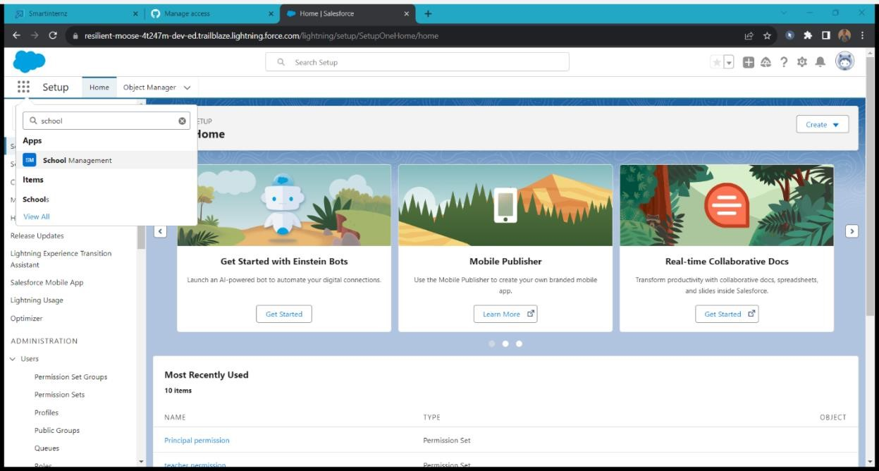

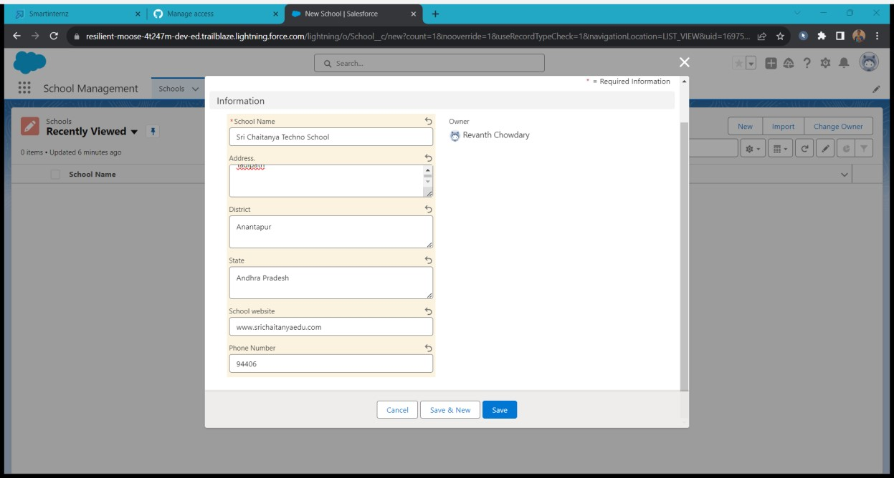

## View Record (School)

1. Click on App Launcher on left side of screen.
2. Search School Management App & click on it.
3. Click on Schools Tab.
4. Click on any record name. you can see the details of the School.

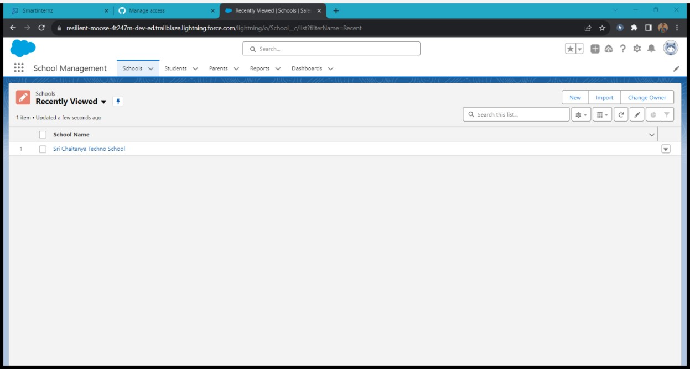

## Delete Record (School)

1. Click on App Launcher on left side of screen.
2. Search School Management App & click on it.
3. Click on Schools Tab.
4. Click on Arrow at right hand side on that Particular record.
5. Click delete and delete again.

# 9.Reports

## Create Report

1. In School Management App click Reports tab.
2. Click New Report.
3. Select the report type as School with students and parents for the report.
4. Click start report.
5. Customize your report, then save and run
6. Give report name – Schools with Students Report
7. Click Save

• NOTE: In this report you can see your all record of the object you selected for reporting (What you Selects in “Select a report type option”).

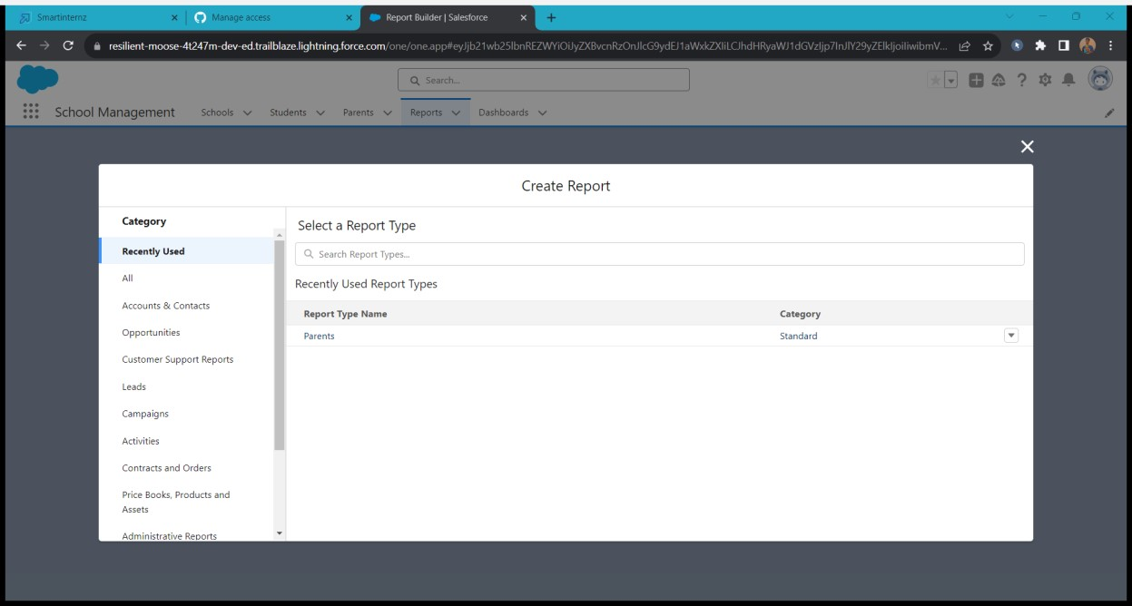

## View Report

1. Click on App Launcher on left side of screen.
2. Search School Management App & click on it.
3. Click on Reports Tab.
4. Click on School with Students report and see records

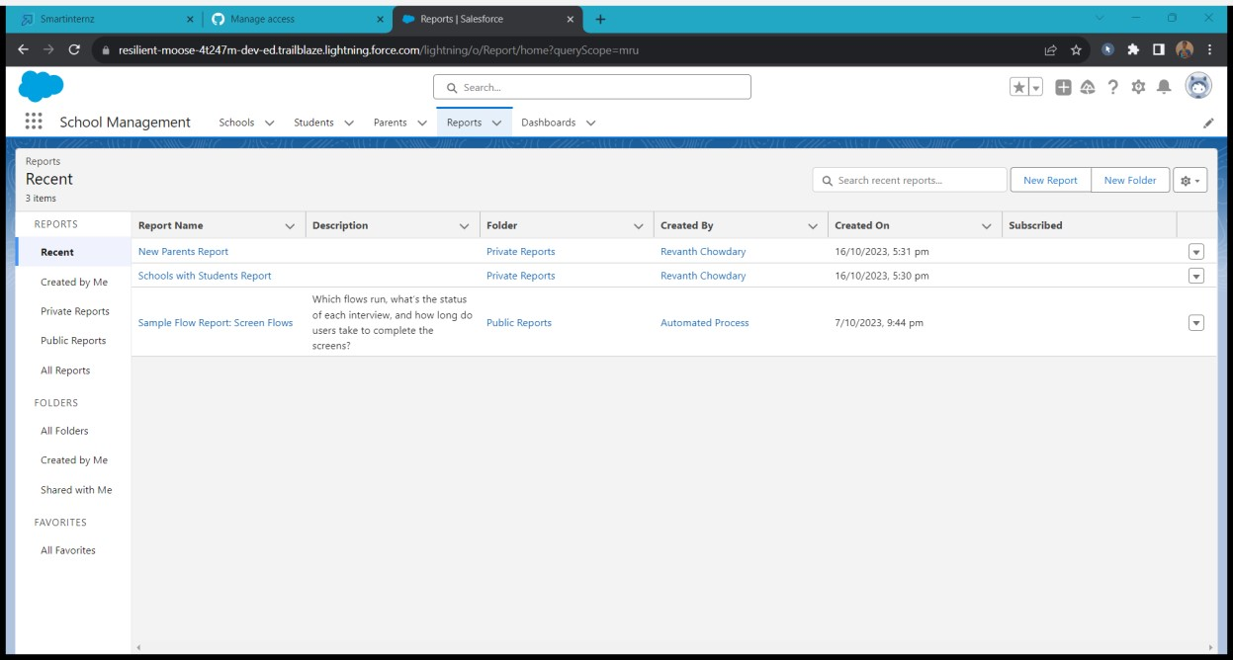

# 10.Triggers

## Write A Trigger

write a trigger whenever the school website is null you should be unable to delete the record.

Go to the gear icon and select the developer console.

From the menu bar click on file and select Apex class.

Now give the class name as schoolHandler

Now Write the below code

public class schoolHandler { public static void beforeDelete(list<School__c> oldlist){ for(School__c s : oldlist){ if(s.Schoolwebsite__c == null ){

s.addError('you cannot delete the record');

}

}

}

}

From the menu bar click on file and select Apex trigger.

Now give the trigger name as Internalmarks

Now write the below code

trigger SchoolTrigger on School__c (before delete) { if(trigger.isDelete){ if(trigger.isBefore){ schoolHandler.beforeDelete(trigger.old);

}

}

}

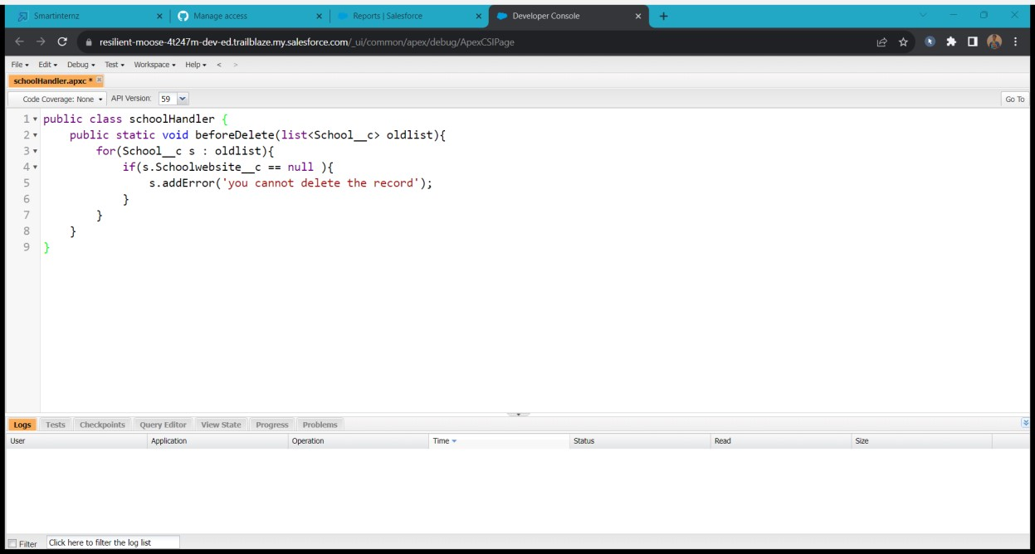

# 11.Flows

## Create Flow

Create a record triggered flow whenever a student record is created it must send the email to the student about their welcome. Click on Gear icon and select setup

In Quick find Box enter flow and select the flows

Click on New flow and Select Record triggered Flows.

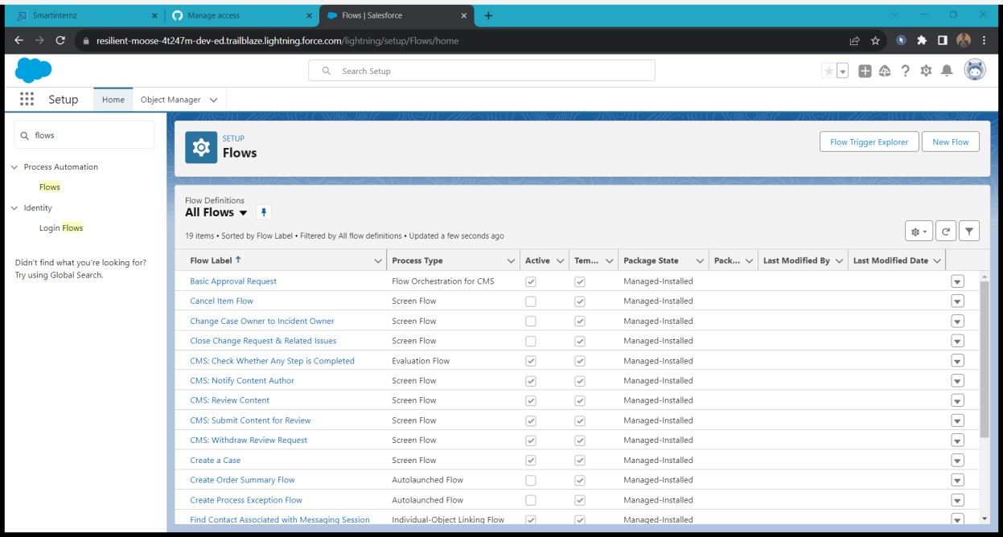

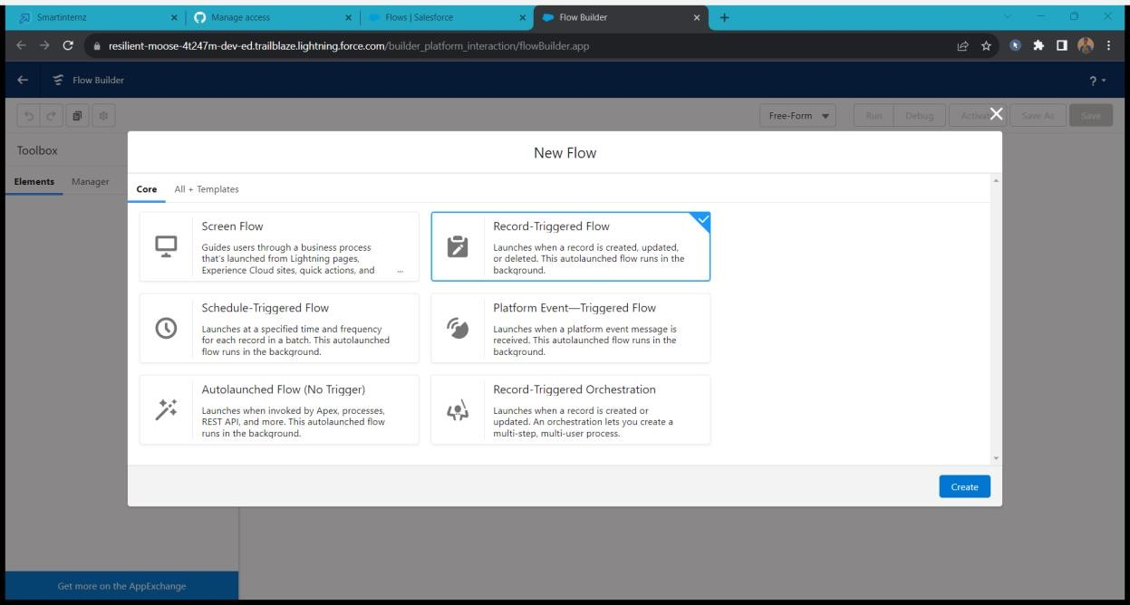

In the search bar type student and click done.

Enter the following details

Label:Student Record Creation

Api Name:Student_Record_Creation( Auto-pupulated)

Body: Hi {!$Record.Name} , we are happy to inform you that you have joined in our

{!$Record.school__r.Name}.

Subject: Record Creation

Recipient email Address:{!$Record.Email__c}

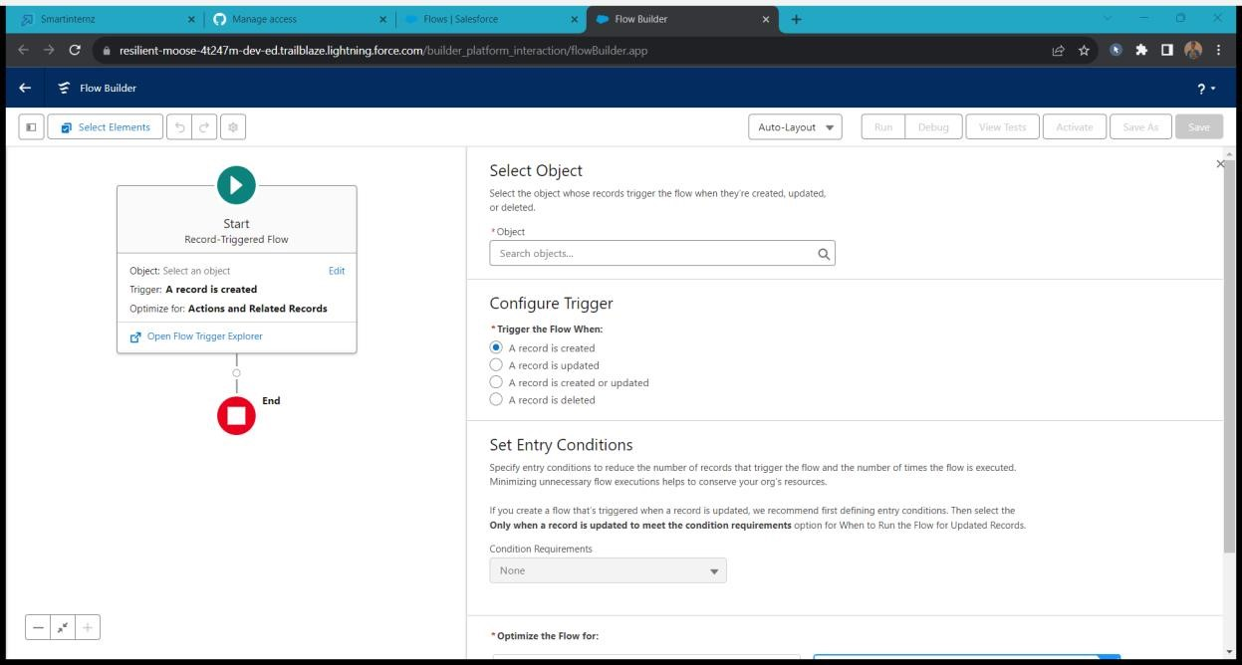

click on done and Click on save Flow label:Student flow Flow API Name:Student_flow and then click Activate.

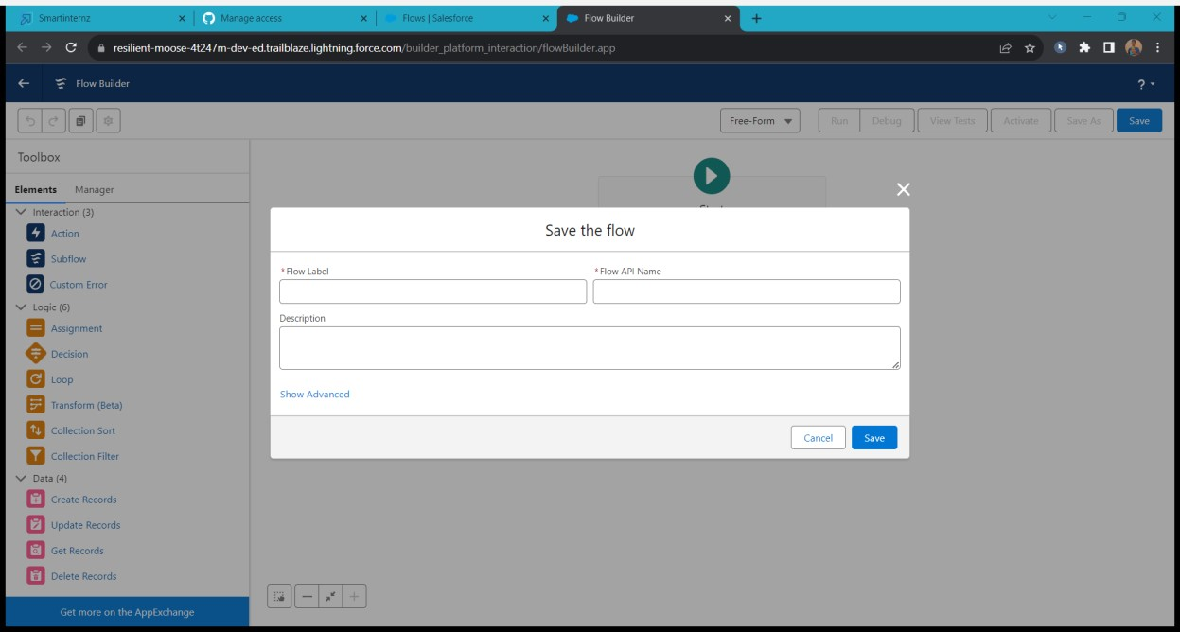

***.…THE END….***